# Advanced Data Centric Web Applications

### Part 1 Check everything is installed OK

* Create a new Maven project in Eclipse by selecting *File/New/Other/Maven/Maven Project* and press *Next*.
* Select *Create a simple project (skip archetype selection)* and press *Next*.

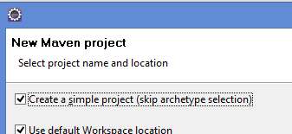

* Enter a Group Id e.g. *com.lab1*.
* Enter an Artifact Id e.g. *lab1-test*.
* Press *Finish*.
* Create a new class called *App* in the *com.lab1* package:

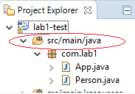

* Create another class called *Person* in the same package as follows:

package com.lab1;

public class Person {

public void sayHello() {

System.out.println("Hello from Person");

}

}

* Update the *App* class as follows:

package com.lab1;

public class App {

public static void main(String[] args) {

Person person = new Person();

person.sayHello();

}

}

* Run the program as Java Application and make sure *“Hello from Person”* is printed.

### Part 2 Singleton

* Create a new Java project in Eclipse by selecting *File/New/Other/Java Project* and press *Next*.
* Give the project a name and press *Finish*.
* Create a class called *Counter* with a variable as follows:

private int total = 0;

* Put the following two methods into the *Counter* class:

public void incrementTotal() {

this.total++;

}

public int getTotal() {

return this.total;

}

* Design the class in such a way that only **one** instance of it can be created.
* Write another class which attempts to create multiple instances of *Counter*.
* What happens and why?

### Part 3 Factory

* Create a new Java project in Eclipse by selecting *File/New/Other/Java Project* and press *Next*.
* Give the project a name and press *Finish*.
* Write the following Interface:

public interface AnimalI {

public String speak();

public boolean canFly();

}

* Write three classes – *Dog, Cat* and *Crow* which implement the above interface as appropriate.
* Write a *Runner* class which instead of directly instantiating an instance of *Dog* as follows:

Dog d = new Dog();

uses a Factory class to do so.